1 – What is Buoyancy?

**OBJECTIVE 1: Be able to tell if something will float or sink from comparing the buoyant force to the gravitational force.**

**Complete the questions below.**

|  |  |
| --- | --- |
|  | Tip 1: Draw the free body diagram.  Tip 2: |

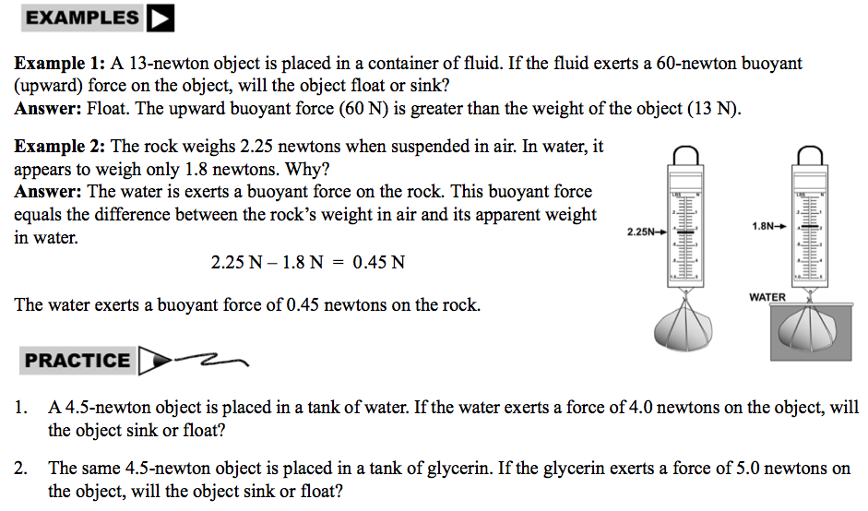

|  |  |
| --- | --- |
|  | Can you tell if something will float or sink from its free body diagram?  ………….………….………….………….………….………….………….………….………….………… |

**OBJECTIVE 2: To be able to calculate the buoyant force.**

**Complete the problems below.**

|  |  |
| --- | --- |
|  | Tip 1: Fbuoyant = dVg where d is density of the fluid (kg/cm3), v is volume of the fluid (cm3), and g is acceleration due to gravity (9.8 m/s2).  Tip 2: If the object is floating, the buoyant force = weight of the object floating.  Tip 3: The denser a fluid is, the greater the buoyant force. |

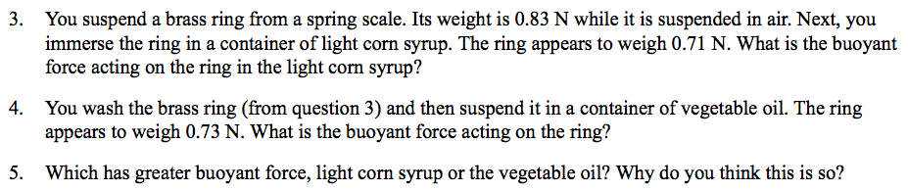





6. A boat displaces 2000L of water. What is the buoyant force acting on the boat?

7. You put a rock into a graduated cylinder. It displaces 5 mL of water. What is the buoyant force on the rock?

8. A beach ball displaces 3mL of water when it is floating. What is the buoyant force?

9. An unknown object has a mass of 5kg and has a volume of 1L. Will the object sink or float. (Hint: calculate the buoyant force and force of gravity and make a free body diagram).

|  |  |
| --- | --- |
|  | Can you calculate the buoyant force?  ………….………….………….………….………….………….………….………….………….………… |