Configuration | Description of what occurred | Energy Transformation(s)
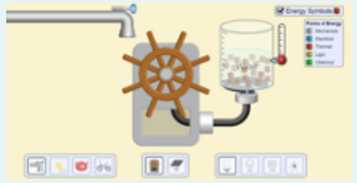  Tap on high, water wheel, heating beaker of water |  | ● Mechanical → Electrical  ● Electrical → Thermal
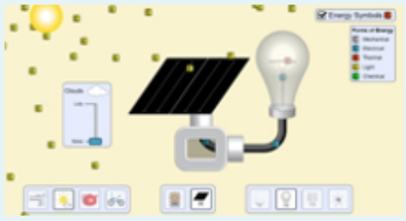  Sun without clouds, solar panel, incandescent light |  | ●
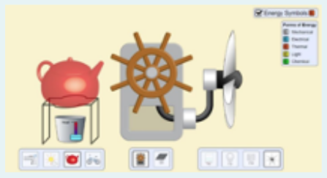  Kettle, water wheel, fan |  | ●
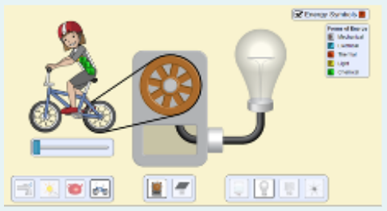  Bike, water wheel, incandescent light |  | ●
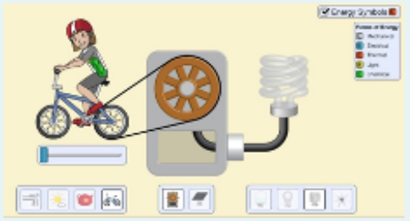  Bike, water wheel, fluorescent light |  | ●
Energy Systems: Conservation, Efficiency, and Transformations [50]

NAME: __________________________________ DATE: ___________________________________

CLASS: __________________________________

Comments on energy conservation and efficiency:

SCORE 1: SCORE 2:

